**Project Design Phase-II**

**Technology Stack (Architecture & Stack)**

|  |  |
| --- | --- |
| Team ID | PNT2022TMID50751 |
| Project Name | A NOVEL METHOD FOR HANDWRITTEN DIGIT RECOGNITION SYSTEM |
| Maximum Marks | 4 Marks |

**Technical Architecture:**

The Deliverable shall include the architectural diagram as below and the information as per the table1 & table 2

**Example: Order processing during pandemics for offline mode**

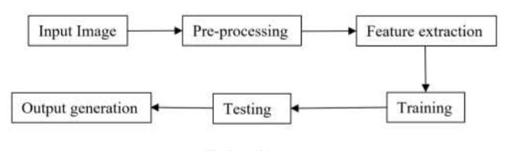

**Table-1 : Components & Technologies:**

|  |  |  |  |
| --- | --- | --- | --- |
| **S.No** | **Component** | **Description** | **Technology** |
|  | User Interface | Web UI through mobile or desktop browser | HTML, CSS, JavaScript |
|  | Application Logic-1 | Using the machine learning | Python |
|  | Application Logic-2 | Using the libraries to pre-processing the image | Python libraires like sklearn |
|  | Application Logic-3 | Different visualization techniques | Python libraries like matplotlib, seaborn etc |
|  | Database | For routing and rendering | Python flask |
|  | Cloud Database | Configuration | IBM Cloud |
|  | File Storage | File storage requirements | Local Filesystem |
|  | Machine Learning Model | To predict the handwritten digits | Handwritten digit recognition model. |
|  | Infrastructure (Server / Cloud) | Application Deployment on / Cloud | IBM Cloud |

**Table-2: Application Characteristics:**

| **S.No** | **Characteristics** | **Description** | **Technology** |
| --- | --- | --- | --- |
|  | Open-Source Frameworks | Angular framework to design the fronted | Angular |
|  | Availability | Cloud platform | Python flask |
|  | Performance | Withstand with many requests at a time | Online deployment to IBm cloud |